Auditable clinical abstraction and question answering: design and evaluation

1. The problem
The task is to build an auditable clinical abstraction from 31 documents and answer questions from it with sources. The packet covers one patient behavioral-health episode (Rowan Mercer, January 5–30, 2026). The difficulty is not finding the right paragraph. It is deciding what actually happened when documents disagree, correct each other or repeat each other.

What is in the packet
- Clinical notes: individual, group and family therapy, medication management and care coordination.
- Attendance records: rosters, an attendance correction, a resent roster copy and a final cancellation register.
- Scheduling and billing: an appointment status export, a draft note with a charge extract, and a group authorization letter.
- Measures: PHQ-9 reviews, plus an imported measure summary that repeats an earlier form.
- Plan: a signed treatment plan with the participation goal: "at least 3 therapy days and at least 150 minutes of patient-present therapy in each Monday–Sunday week."

Why a correct answer is hard
Five situations from the packet show the hard parts.
Situation | Example from the packet | What a naive system gets wrong
Two signed accounts disagree | For session HG-E115 on Jan 26, BH-D110 records contact "09:00–09:50, 50 minutes"; BH-D111 records "09:10–09:50, 40 minutes". Both are signed, final and same-day. | Picks one silently, or averages to 45 minutes, which no document supports
A correction supersedes a record | BH-D103 corrects HG-E110's departure from 11:30 to 11:15 and states that only that field changes | Uses the original 11:30, or discards the whole original roster
A copy repeats a superseded value | BH-D104 is the original roster resent on Jan 26, still showing 11:30 | Counts the copy as independent confirmation of 11:30
Something looks like attendance but isn't | Bookings, an authorization, a charge extract, a draft note | Counts a scheduled or billed visit as delivered
Arithmetic across rules | Minutes = patient presence minus breaks and telehealth gaps; weekly goals per Monday–Sunday week; the last week is partial (Jan 31–Feb 1 unobserved) | Model arithmetic errors, or declaring a partial week "not met"

2. The clinical abstraction
The abstraction is a structured record of the patient’s care, built from the documents. A model reads each document into quoted observations; code turns them into events and facts using the rules in policy.toml. Every fact traces back to a source line.
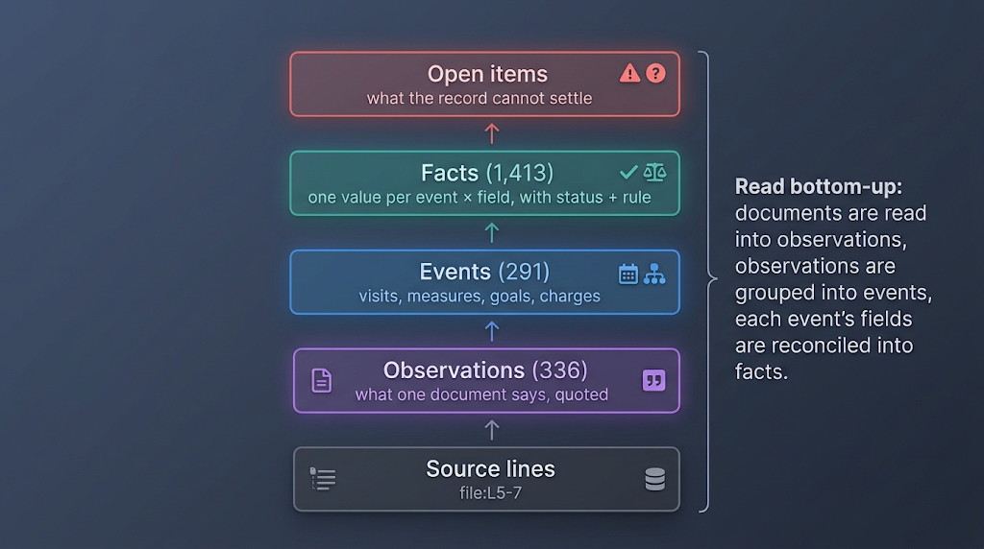
The four layers of the record, read bottom-up.
Layer | What it is | Example
Observation | What one document says, each value with its quote and lines | BH-D110 L5-7: HG-E115 contact 09:00–09:50
Event | The real-world thing observations describe | HG-E115, the January 26 individual session
Fact | One value per event and field, with status, rule and evidence | HG-E110 departure 11:15, established by a signed correction
Open item | What the record cannot settle | HG-E115 start: 09:00 or 09:10
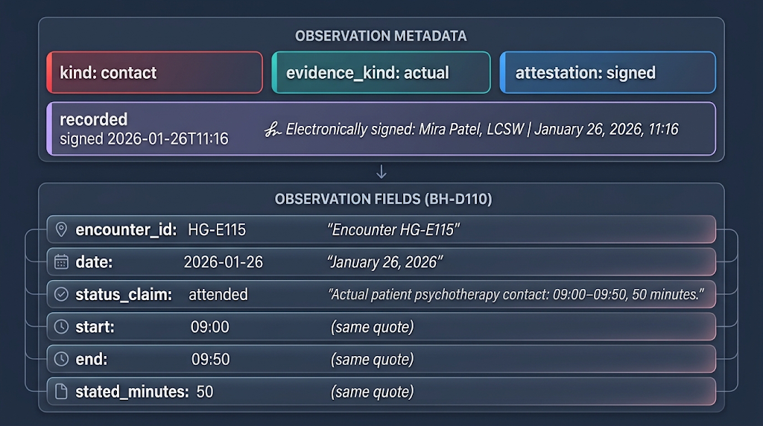
An observation from BH-D110. Every value carries its quote; the metadata (evidence kind, attestation, signed time) is what reconciliation uses to rank sources.

How the record is built (per patient)
- Patient scope. The record’s patient is the MRN most documents state. A document with another MRN or date of birth is set aside as an open item.
- Link. Observations with the same encounter ID and issuer become one event; without an ID they are matched on date, service, time and participants. Weak matches are reported, never merged.
- Reconcile. For each event and field: keep only admissible evidence, apply signed corrections to the fields they name, rank by attestation and timing, then decide the status. Equal sources that disagree stay as scenarios.
- Derive. Minutes are presence minus breaks and gaps, per account; a visit counts toward the goal when attended and the service is eligible; weekly goals are judged per threshold.
Example: HG-E113 takes its times from the register (BH-D108) and its break from the activity record (BH-D107): (11:30 − 10:30) − 15 = 45 minutes, citing both.
Each fact gets one of four statuses:
Status | Meaning | Count
documented | One source states it; nothing contradicts it | 1,524
corroborated | Two or more independent sources agree (copies do not count) | 77
established | A rule chose between sources, such as a signed correction or a computation | 27
conflicting | Sources of equal standing disagree; every value is kept as a scenario | 4

Output
abstraction.json holds the full record; abstraction.md is the readable view, with every row linked to its source lines. For this packet: 12 therapy sessions on 11 days, 585 or 595 minutes.
Week | Therapy days (goal ≥ 3) | Minutes (goal ≥ 150) | Goal
Jan 5–11 | 3 | 140 | not met
Jan 12–18 | 2 | 120 | not met
Jan 19–25 | 3 | 180 | met
Jan 26–Feb 1 (partial) | 3 | 145 or 155 | cannot be determined
Adding a document extracts only that document and rebuilds the record in under a second; changes.md lists every fact that changed.

The policy file (policy.toml)
One versioned file holds the domain rules, so the engine code stays generic:
- What to extract: observation kinds (contact, interval, charge, measurement, medication, goal, finding) and their fields.
- How to judge evidence: which evidence kinds may set which field, precedence (signed > unsigned > draft), and what counts as attended.
- Vocabulary and linking: service names, match weights and copy detection.
How it is produced. It was written during development from standard documentation practice and this packet’s conventions, and is reviewed like code. It is read-only at runtime, and its version is stamped into every record.
A new patient needs no policy change: patient facts, including the treatment goal, come from that patient’s own documents, never from the policy. A new clinic is run on sample documents first; unrecognised services or formats show up as open items and extraction issues, and are added to the policy after clinical review. Changing a rule needs only a rebuild; changing what to extract re-reads the documents.

3. Architecture
The system has two phases. Building turns documents into the record and runs once per document set. Answering runs once per question against that record. 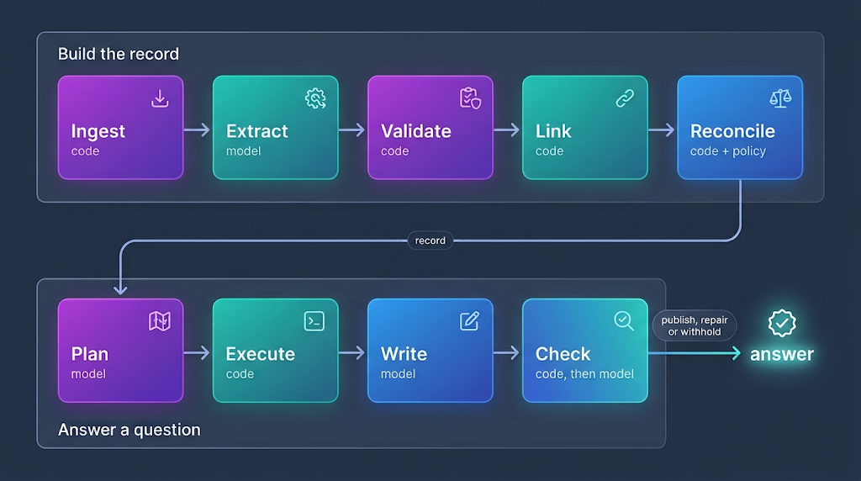
The build is deterministic after extraction: the same observations always produce the same record.
Stage 1: ingest
Each text file is split into numbered lines and blocks.
A block is a paragraph between blank lines, and every table row is its own block. A block's ID is its file and line range, such as BH-D110_individual_primary_record_2026-01-26:L5-7.
Documents are identified by SHA-256, so an unchanged file is never re-read.

Stage 2: extract (model, one call per document)
A model (Claude Sonnet) reads one document at a time and returns observations in a fixed schema. The prompt and schema are generated from the observation kinds in policy.toml: contact, interval, charge, measurement, medication, plan goal, finding and document metadata. Two instructions matter most:
- Record what the document says, not what is true. A booking is extracted as a planned contact, not an attended one.
- Quote every value. Each field needs the exact words stating it and the block they are in.
Outputs are cached by the hash of the prompt and document. Each document is read twice, independently, and a focused re-read settles disagreements; for the packet this took 12 re-reads, about 7 minutes and $3.92.

Stage 3: validate and sweep (code)
Validation enforces the quoting rule mechanically: a value must be readable from its own quote. A time must appear in the quote. A date must be stated in it, in any common format. A duration must be stated, not computed from two times. An ID must match. Values that fail are rejected and logged. The packet had 18 rejections, mostly finding dates the quoted sentence did not state; those findings take their encounter's date by a named rule.
The sweep then scans each document for times, dates, durations, IDs and scores that no quote covers. Documents with uncovered mentions get one targeted re-extraction. Of 11 uncovered mentions, 3 remained and were recorded as open items.

Stage 4: link (code)
Observations are grouped into events:
- Shared identifier: the same encounter ID from the same issuer is the same event. Issuer names are compared after dropping generic words ("Behavioral", "Health", "Clinic"), so different spellings of one organisation match. A reused ID from another organisation becomes a separate event (HG-E115@Other-Clinic).
- Weighted match, for observations without an ID: date 0.3, service 0.3, equal times 0.4 (overlapping 0.3), participants 0.2, issuer 0.1. At 0.8 or above they are linked; from 0.5 to 0.8 they stay separate and a candidate link is reported.
- Copy detection: two documents sharing at least 80% of their 5-word shingles are copies. A copy is not independent evidence, and it falls with its original.
For example, HG-E110 links five observations from four documents: the group note (BH-D101), the original roster (BH-D102), the correction (BH-D103) and the resent copy (BH-D104).

Stage 5: reconcile (code + policy)
For each event and field, one algorithm runs four steps, using only rules from policy.toml:
- Admissible: drop evidence the policy excludes for this field. Attendance, times and durations accept only actual evidence; a service name may also come from a booking or bill.
- Supersede: a signed correction replaces only the fields it names, so BH-D103 replaces HG-E110's departure but not its arrival. A copy falls with its original, which retires BH-D104's 11:30. A stated duration falls when the times it restates are corrected.
- Rank: attestation first (signed > unknown > unsigned > draft). Then an account made within a day of the event outranks a later one of the same rank, but only if every competing account's authoring time is known.
- Decide: the status and rule as in Section 2. If equal-ranked sources still disagree, every value is kept as a scenario.
Derived fields follow the same pattern:
- Minutes: each surviving account's presence minus its breaks and gaps, giving one scenario per account.
- Disposition: attended, and the service counts under a documented care goal.
- Weekly goals: evaluated per threshold, per Monday–Sunday week, with partial weeks and uncertain attendance kept as "cannot be determined".
The build step itself makes no model calls and finishes in under a second. Its outputs are abstraction.json (the full record) and abstraction.md (a readable rendering with timelines, the encounter table and open items).

4. Answering a question end to end
A question goes through five steps: plan, execute, write, check and frame. The example below is a real run on the current engine:
Were the documented weekly treatment goals met?

1. Plan (model)
The planner sees the question and a catalogue of the record (its sources, fields and goals), not the documents. It writes queries in a small query language, each stating the population it counts, plus a checklist of what the answer must cover. Here it wrote two queries:
from encounters where date >= 2026-01-05 and date <= 2026-01-30
and disposition = included group_by week
select count_distinct(date), goal_met()
from encounters where date >= 2026-01-05 and date <= 2026-01-30
and disposition = included group_by week
select sum(minutes), goal_met()
Checklist: was the ‘at least 3 days per week’ goal met each week; was the ‘at least 150 minutes per week’ goal met each week.

2. Execute (code)
Code runs the queries against the record. goal_met() reads the goal from the signed treatment plan and judges each threshold per Monday–Sunday week. A conflicting value is carried as scenarios, so week 4’s minutes are 145 or 155, never 150.
Week | Therapy days | Minutes | ≥ 3 days | ≥ 150 minutes | Goal
Jan 5–11 | 3 | 140 | met | not met | not met
Jan 12–18 | 2 | 120 | not met | not met | not met
Jan 19–25 | 3 | 180 | met | met | met
Jan 26–30 (partial) | 3 | 145 or 155 | met | cannot determine | cannot determine
Every result row (R1.1–R1.4, R2.1–R2.4) lists the encounters and facts behind it, so each number traces back to source lines.

3. Write (model)
The writer gets the results, the facts behind them, the open items and the relevant source passages. It returns typed statements, each citing result, fact or source IDs:
Statement | Kind | Cites
The weekly goals (at least 3 therapy days and 150 patient-present minutes per Monday–Sunday week) were met in only one of the four weeks, January 19–25. They were not met in weeks 1 and 2, and cannot be determined for week 4 because of a documentation conflict. | inference | R1.1–R1.4, treatment plan L12
At least 3 days: met in weeks 1, 3 and 4 (3 days each); not met in week 2 (2 days). | value | R1.1–R1.4
At least 150 minutes: not met in week 1 (140) or week 2 (120); met in week 3 (180); week 4 cannot be determined, because the January 26 session is 40 or 50 minutes in two signed notes, making the total 145 or 155. | conflict | R2.1–R2.4, open items, F-b891363d

4. Check (code, then model)
Code checks run first, and any failure blocks publication:
- Numbers: every number must appear in a cited result or fact, or be arithmetic over cited numbers.
- Goal outcomes: “met”, “not met” or “cannot determine”, per threshold and overall, must match goal_met().
- Conflicts: a conflicting value cannot be stated as a single number.
- Dates and weekdays must match the cited evidence; “not documented” claims are looked up in the record.
A small model (Claude Haiku) then checks that every part of the question and checklist is covered, that each statement is supported by what it cites, and that each counted population is the one asked for. Here every check passed on the first draft.
If a check fails, code repairs what it can prove and the model gets one repair attempt. An answer whose only problem is coverage is published as partial, with the gaps listed; anything else is withheld with its reasons.

5. Frame (model + code)
A final step orders the checked statements: the direct answer first (statement 1), then only the context needed to read it (statements 2 and 3). It never rewrites a statement, so nothing unchecked reaches the answer.

Cost
Four model calls per question (plan, write, check, frame), plus a repair when needed. Across the 65 benchmark questions this averaged $0.19 and a median of 42 seconds per question. Every call is cached, so asking the same question again costs nothing.

5. Design decisions and alternatives considered
One principle: the model reads, code decides. Models read varied clinical text well but are unreliable at arithmetic and at applying precedence rules consistently. So each document is read once into quoted observations, and code decides what is true using written rules.

Decisions
Decision | Why | Trade-off
Build a record first, then answer from it | Reconciliation happens once, by rule, and every answer uses the same record | An extraction pass up front
Every value quotes its source | Nothing computed or inferred enters the record | Durations are computed later, by code
Rules live in a policy file | New wording or document types need a policy entry, not new code | Rules must be written to hold across document sets
Conflicts are kept as scenarios | "40 or 50 minutes" is honest; averaging invents a value | Longer answers
Questions compile to queries | The same question gives the same numbers, and new questions need no new code | The planner can pick the wrong population; one re-plan is allowed
Answers are checked by code before publishing | Numbers, dates and goal outcomes are verified by lookup; failures withhold | Some prose reads stiffly
Each document is read twice | Code compares the readings and catches random extraction errors | Doubles extraction cost
Authoring time, not receipt time | A late addendum outranks the note it corrects; a resent copy does not | Depends on signatures being extracted correctly

Alternatives considered
Alternative | Why not
Vector search + answer (standard RAG) | Cannot guarantee a count is complete, and reconciliation happens inside each answer, unaudited
One long-context call over all documents | Facts in the middle get missed, results vary between runs, and there is no trace of why a source won
The model as reconciler | Not deterministic, and its reasons cannot be verified
A fixed tie-break (latest wins) | The documents give no basis for it, and it hides exactly what a reviewer needs to see

6. Evaluation

How the evaluation sets were built
Development benchmark (65 questions). The five example questions are kept verbatim as DEV-01–05, and 60 more (DEV-06–65) were written from the 31 documents. Each question has:
- a reference answer;
- a checklist of required facts, all needed for full marks;
- the failure modes it is designed to expose, such as a document counted as a visit, a charge treated as attendance, a same-day duplicate or a conflict averaged away;
- source excerpts with file and line ranges;
- for aggregate questions, a structured answer (counts, minutes, weekly results) scored field by field.
The set spans 9 easy, 29 medium and 27 hard questions. It covers retrieval, classification, interval arithmetic, deduplication, corrections, unresolved conflicts, weekly thresholds, missing information and false premises, and every document supports at least one question. A reference ledger fixes the anchors: 12 sessions, 11 days, 585 or 595 minutes, and weekly results of not met, not met, met, cannot determine. Gold data is read only by the evaluator, never by the engine.
Held-out set (15 questions). Written from the documents in the same format, with reference answers, and kept out of development except that HO-02 informed one earlier fix. It covers weekly goals, PHQ-9 change, undelivered appointments, coordination, partner-only time, same-day contacts, clinicians, signatures, a correct absence claim and elapsed time across a correction.
Results in brief. On the 65-question development benchmark the engine published every answer and scored 119/130 with a blind model judge (55/65 fully correct). Every exact calculation was right (4/4 questions, 55/55 fields). All five development questions were published; in the benchmark run DEV-02–04 scored full marks and DEV-01 and DEV-05 lost one point each for detail, and a later cold re-run on the current code scored full marks on all five, although a manual read found three wording errors the judge missed. On 15 held-out questions it scored 26/30. Rebuilding the record from nothing gave an identical episode ledger. The main weaknesses are citation recall (0.43), answers that sometimes include the wrong detail, and a model judge that misses wording errors. Two known correctness gaps (goal replacement and weighted linking) are not triggered by this packet but are listed below.

What we ran
Evaluation | Question it answers | Size | Graded by
Offline tests | Do the rules, arithmetic and checks behave as specified? | 144 tests, plus 2 browser tests | pytest, no model calls
Development benchmark | Are answers correct, complete and well cited? | 65 questions (DEV-01–05 required) | Deterministic scorer + blind model judge (Sonnet 4.6, the model that also writes the answers)
Held-out set | Did we overfit to the benchmark? | 15 questions | Same judge and rubric, graded separately
Stability | Is the record reproducible? | Full rebuild from nothing | Fact-by-fact comparison of two builds
Changed-input scenarios | Does the record respond correctly when documents are added? | 13 scenarios (engine 0.2) | Deterministic record and answer checks + the same judge

Metrics
Metric | What it measures | Why we use it
Judge factual (0–2) | Correctness against the reference answer and required facts | Primary quality measure
Judge evidence (0–2) | Whether the cited source lines support the answer | Auditability
Exact calculations | Structured numeric fields against gold values | Arithmetic must be exact, not close
Citation precision / recall / F1 | Cited blocks vs gold source lines (micro and macro) | Evidence coverage and precision
ROUGE-1 / ROUGE-L / BLEU-4 | Word overlap with the reference answers | Secondary only: rewards matching wording, not correctness

Development benchmark (65 questions, engine 0.3, policy-2)
Measure | Result
Published | 65/65 (63 answered, 2 partial)
Judge factual | 119/130 (mean 1.83; 95% interval 1.72–1.92, exploratory)
Fully correct (factual 2) | 55/65
Judge evidence | 1.92
DEV-01–05 | 5/5 published; DEV-02–04 factual 2, DEV-01 and DEV-05 factual 1; all evidence 2. Cold re-run on the current code: factual 2 and evidence 2 on all five (see below)
Exact calculations | 4/4 questions, 55/55 structured fields
Citations, micro P / R / F1 | 0.61 / 0.43 / 0.50
Citations, macro P / R / F1 | 0.71 / 0.53 / 0.56
ROUGE-1 / ROUGE-2 / ROUGE-L | 0.35 / 0.13 / 0.23
BLEU-4 (corpus) | 0.052

Reading the lexical scores. ROUGE and BLEU are low because answers are phrased differently from the references, not because they are wrong: a question scored factual 2 can have near-zero BLEU. We report them for completeness and draw no conclusions from them.
Reading the citation scores. Precision is higher than recall. Answers cite the lines behind each statement, while the gold set includes every block overlapping a gold passage. Recall is the weaker side: answers leave out supporting lines the reference includes.
Wording errors the judge missed. A manual read of the re-run DEV-01–05 answers found three errors that change no number, and all three still scored full marks. DEV-01 says eight encounters “were attended but excluded”, but the list includes two no-shows and two cancellations. DEV-05 says “Rowan and the patient both reported”; Rowan is the patient. DEV-02 calls both January 26 notes “primary clinical records”; BH-D111 is the participating clinician’s record. The judge is the same model that writes the answers, so its scores are treated as advisory.

Held-out set (15 questions)
15/15 published; judge factual 26/30, evidence 1.60. HO-02 informed an earlier fix, so the set is not fully held out. The four lost points:
- HO-03: counted the coordination call among the appointments not delivered.
- HO-05: left out the 15 partner-only minutes of January 30.
- HO-06: marked down for naming the January 19 individual clinician, who is correctly named in BH-D105, so this is a grader error.
- HO-10: gave the day count without listing the days.
After these results were known, the set was regraded with the same evidence the development judge sees, which gave 27/30 (evidence 1.87). The first grading is the result reported here.

Stability
The record was rebuilt from nothing, with every model call fresh, and compared with the submitted build. The episode ledger is identical: every count, total, weekly result and encounter contribution. Of 402 non-text facts, 22 differ, and none of them changes a count, total or weekly result. They are mostly administrative contacts that one build recorded and the other did not, or a difference in how strongly a value is confirmed (one source vs several).
Across the two readings of each document, 40 points disagreed: 30 were settled by a focused re-read, and 10 remain open items, mostly outreach-call dates and times.
Changed-input scenarios. Thirteen scenarios each add documents to the packet with a known expected effect: a late-entry addendum, a CSV scheduling export, a session documented only by a stated length, an e-mail correction, an OCR-damaged draft, a paid claim line for a cancelled visit, another patient’s note, a reused visit number at another clinic, a withdrawn plan, a plan amendment, a JSON video-platform log, a re-imported measure form and an equal-standing no-show note. Record checks passed 30/30; 14/14 answers were published, 13/14 passed their answer checks, and the judge scored 26/28. These ran on engine 0.2 and were not re-run for 0.3.

What didn’t work
Problem | Where it shows | Cause
Answers include the wrong detail | DEV-01, 05, 19, 31, 49, 56, 58, 59, 60 (1 point each); HO-03, 05, 10 | The writer adds context the question did not ask for, omits a fact the reference expects, or applies a statement to the wrong date or week
Linking question answered from the wrong view | DEV-61 (0 points) | Listed unresolved candidate links instead of each encounter’s linked documents
Low citation recall | 0.43 micro | Answers cite only what each statement needs
Unfamiliar value formats | Dates and times written in words or as compact timestamps ("half past two", 202601291400) | The validator reads only numeric date and time formats, so such values are rejected rather than read
Goal replacement ignores attestation | Goal handling in this version | An unsigned draft plan can replace a signed goal
Weighted linking can merge distinct sessions | Linking without a shared visit ID (not triggered in this packet) | Participants match on any shared word, so two same-day sessions from different documents whose clinicians share a credential (e.g. LCSW) reach the 0.8 link threshold with no time overlap
Judge misses wording errors | DEV-01, 02 and 05 in the re-run (full marks despite errors) | The model judge compares facts with the reference and does not catch every wrong word; a manual read found three

How we would improve it
- Fix the three correctness gaps: make goal replacement respect attestation, require overlapping times before a weighted match can link (and compare participants by full name), and widen the value parser (words, HL7 and ISO timestamps). Add each as a regression test.
- Raise citation recall: for each statement, also cite the lines behind every fact it depends on, then measure the precision cost.
- Tighten answer scope: check statements against the question’s named events, dates and quantities, require every figure the checklist names, and check in code that status words such as “attended” match each encounter’s reconciled status.
- Extend to a second patient: run the synthetic second-patient packet (17 documents from a different clinic, 12 questions with reference answers) end to end, and check patient scoping when both patients’ documents are mixed in one folder.
- Strengthen the evaluation: clinician-adjudicated references, three graded runs to measure judge noise, and a judge from another model family.

7. Limitations and future work
The largest open question is generality. The design is general, but everything was built and tested on one synthetic patient in one specialty. The most valuable next step is a second, independently written record set, with references adjudicated by a clinician.

Limitations
- One patient, one domain. The policy file was written for outpatient behavioral health. It is data, but it is untested on other specialties or inpatient records.
- Hand-set link weights. Weights (date 0.3, service 0.3, time 0.4 …) and thresholds (0.8 link, 0.5 candidate) were chosen by judgment, not estimated.
- Extraction can miss. Validation stops invented values and the sweep catches uncovered numbers. A fact the model never extracts, stated in prose without numbers, can still be missed.
- Model reviewer noise. The Haiku reviewer both misses problems and invents them. Code checks cover numbers, dates, goals and weekdays, but not narrative scope.
- Text only. No PDF, scanned-image or HL7/FHIR ingestion.
- Long answers. Carrying conflicts and provenance makes answers longer than a clinician may want.
- Evaluation depth. One model judge, one run per version, and author-written references (Section 6).

Future work
- First fixes. Widen the value parser to read dates and times written in words and compact timestamps, make goal replacement respect attestation so a draft plan cannot replace a signed one, and require overlapping times before a weighted match can link two sessions. Then test on a second patient.
- Cheaper reading. Fine-tune a small model for extraction, trained on the system's own validated, cross-checked observations. Keep the larger model for disagreements and hard cases.
- More formats. Read CSV, JSON and HL7 directly with code, so only prose needs a model.
- More clinics. Add each clinic's service names and conventions to the policy file, reviewed by a clinician.
- More patients. One record per patient, rebuilt only when a new document arrives.
- Long documents. Read long charts in windows of whole blocks that end at natural breaks, such as a new note or visit. Each window gets the document header, blocks stay the unit of citation, and all windows share the document's signature, so they never count as independent sources.
- What stays in code. Reconciliation rules and arithmetic are not fine-tuned. They stay deterministic so every answer can be traced.

8. Running the system
The system needs Python 3.13, uv, Node 24 and Docker (or PostgreSQL 16). The Anthropic API key goes in .env as EHR_ANTHROPIC_API_KEY and stays on the server. Model outputs are cached by content, so a re-run pays only for what changed.

Web application (main entry point)
make dev is the main command. It starts the web app, the API and the worker.
make setup # install Python and Node dependencies, create .env
make db # start PostgreSQL (Docker)
make migrate # create the database schema
make dev # web app localhost:3000, API docs 127.0.0.1:8008/docs
Open the web app and upload the TXT documents. Records are routed to their patient by MRN and date of birth, and the case opens automatically. The worker builds the record in the background; the Clinical record, Documents and Ask a question views then show every value with a link to its source lines. Adding a document rebuilds the record, extracting only the new file.

Command line (engine only)
The engine also runs on its own, without the database, reading documents/ directly. This is the quickest way to reproduce the submitted outputs or try new questions and documents.
make evaluate # record, 65 answers, metrics, stability -> submission/
make heldout # 15 held-out questions, graded separately
make test # offline tests, no model calls
# answer a question file
.venv/bin/python -m record_engine ask --questions FILE --out DIR
# add a document, rebuild the record, write changes.md
.venv/bin/python -m record_engine add NEW.txt
# fact -> rule -> evidence -> source lines
.venv/bin/python -m record_engine trace HG-E115 --out submission
# facts that changed between two records
.venv/bin/python -m record_engine diff --before OLD.json

Where each output lives
Path | Contents
submission/abstraction.md | The readable record: encounter ledger, weekly goal results, facts by event, open items, with source links
submission/abstraction.json | The reconciled record: every fact with its status, rule and quoted evidence
submission/observations.jsonl, extraction_issues.jsonl | Observations from each document, and values validation rejected
submission/answers.md, answers.json | The 65 benchmark answers (DEV-01–05 first), with sources, calculations and checks
submission/run_stats.json, extraction_stats.json | Cost and time per question and for extraction, including the cross-check report
submission/benchmark/ | Metrics, judge grades, held-out results and stability check
record_engine/policy.toml | All domain rules
record_engine/heldout/ | Held-out questions, references and grader
record_engine/tests/, tests/ | Engine, metamorphic, changed-input and service tests

Code map
Module | Role
ingest.py | 1 Ingest: lines and blocks
extract.py, llm.py | 2 Extract: prompt generated from the policy; cached model calls and cost tracking
crosscheck.py | 2′ Second independent reading, comparison and focused re-read
validate.py, values.py, dates.py | 3 Validate and sweep
link.py | 4 Link: events and copy detection
reconcile.py | 5 Reconcile: facts, minutes, disposition, open items
query.py | 6–7 Query language and scenario arithmetic
qa.py, evidence.py | 6, 8, 9, 10 Plan, write, check, frame
render.py, changes.py | Readable outputs, trace and diff
evaluate.py, text_metrics.py | Benchmark judge, deterministic metrics, stability check
services/clinical, apps/web | API, worker and database; web application

References
The design draws on the work below. Each entry notes what it contributed.
Work | Used for
Google, LangExtract (2025) | Extraction grounded in exact source spans (Stage 2)
Dong, Berti-Equille and Srivastava, Integrating Conflicting Data: The Role of Source Dependence (VLDB 2009) | Copies are not independent corroboration (Stages 4–5)
Dong et al., Knowledge-Based Trust: Estimating the Trustworthiness of Web Sources (VLDB 2015) | Weighting sources by reliability rather than counting votes
Fellegi and Sunter, A Theory for Record Linkage (JASA 1969); Splink | Weighted field agreement with link and candidate thresholds (Stage 4)
Ratner et al., Snorkel (VLDB 2017) | Rules as data, reviewed and versioned like code
Shi et al., EHRAgent (2024); Lee et al., EHRSQL (2022) and TrustSQL | EHR question answering through executable queries, with abstention (Stages 6–7)
Adams et al., LongHealth (2024); Liu et al., Lost in the Middle (TACL 2024) | Why one long-context call over all documents is unreliable
Wu et al., SourceCheckup (2025); Chung et al., VeriFact (2025) | Checking that cited sources support each claim (Stage 9)
Asgari et al., CREOLA (2025) | Clinical summaries omit more often than they fabricate, so completeness and absence claims are checked
Mohri and Hashimoto, Language Models with Conformal Factuality Guarantees (ICML 2024) | Future work: calibrated abstention
Hyun et al., METAL, metamorphic testing of LLMs (2024) | Changed-input tests with known expected effects
Panickssery et al., LLM Evaluators Recognize and Favor Their Own Generations (2024) | Why the model judge's score is treated as advisory

